Bitcoin Private/ Public Key Cryptography:
bitcoin uses elliptic curve cryptography with the specific curve secp256k1 where the curve y^2 = x^3 + ax +b becomes y^2 = x^3 + 7.

Elliptic curve cryptography (ECC) enables higher security with a key compared to an RAS key of the same size. It has elliptic curve cryptographer has a higher level of security for smaller keys compared to RSA. E.g a 256 ECC key is equivalent in security to a 3072 bit RSA key, and a 384 ECC key is equivalent in security to a 7680 bit RSA key.

The elliptic curve is a curve of the form y^2 = x^3 + ax +b which is a plane curve over a finite field (a field where there is a finite number of elements and /*-+ are all defined). Recommended algorithms include Ellipic Curve Diffie-Hellman (ECDH) for key exchange and Elliptic Curve Digital Signature Algorithm (ECDSA) for digital signatures.

There are many elliptic curve perameters in generating private and public keys, where not all parameters provide a secure elliptic curve to generate keys with.

Where RSA uses prime number factorisation to provide the foundation of secure one-way functions, elliptic curve cryptography uses the notion of an ellecptic curve to generate a one way function.

- a simple overview of ECC, given a curve, a starting point A, end point Z, max value (finite) keysize (x = keysize), an operation “dot” exists where point “dot” point creates a line segment through the curve, and due to the symetric nature of the curve, then end point of the line segment and curve intersectioncan be dragged down or up until intersecting the curve again at which it can be “dot”ed again and reflacted to the other side of the curve. The number of “dot” operations represents the private key in this case. This method produces the one-way function which is computationally infeasible to crack the larger the key size.
Source: https://www.youtube.com/watch?v=dCvB-mhkT0w

- another overview of ECC: given a staring point A, and an operation + (not addition, bit tangent addition) we a+a N many times where a + a is generates a tangent lin from a and intersects the curve at some point, the point is flipped to other dimention of curve (from +ve y axis to -ve y axis or vise versa) and then + again to itself. The private key is the number of times the + operation was preformed and the public key is the (x, y) coordinate of the end point after N + operations.
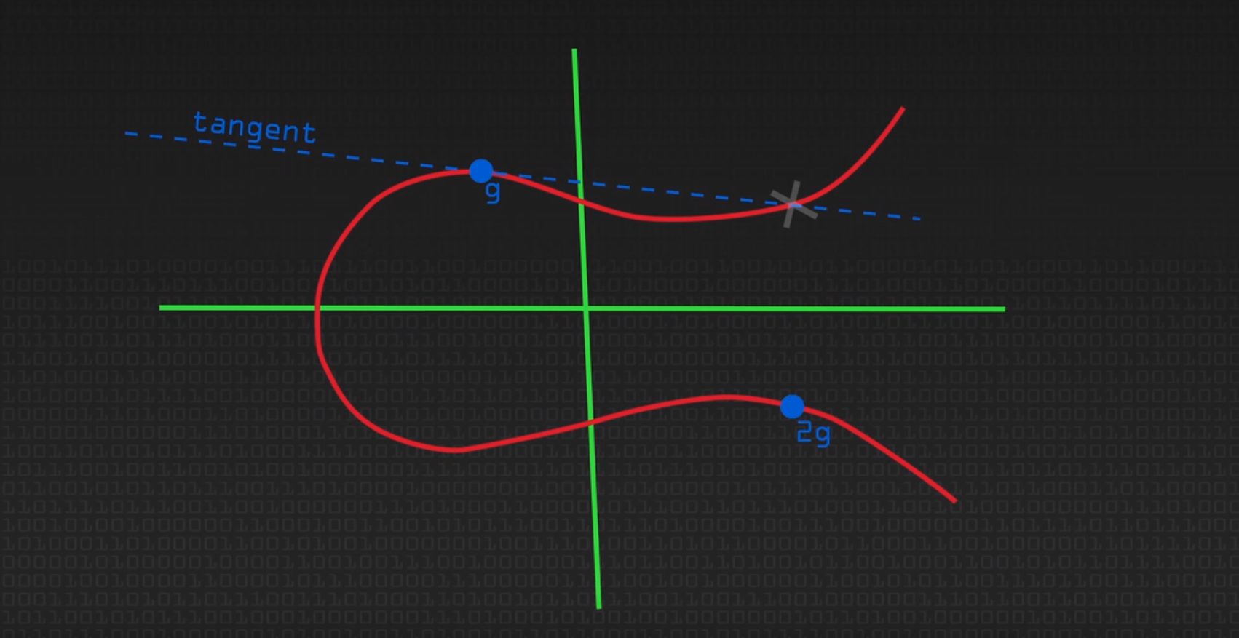
As seen above a tangent is drawn from the start point g, intersects the curve and then (this intersection point is)reflected over the x-axis to 2g, that is the first example of the + operation. The 3g would be then next + operation where a line is drawn between g and 2g and furthur drawn until it intersects the curve again where it would then be reflected over the x axis… next would be a line drwan from 3g to g and further drawn until it intersects the curve again …..
-this creates the elliptic curve discrete log problem which is difficult to solve yet easy to compute giving it the attribuites of a one-way function.
Source: https://www.youtube.com/watch?v=NF1pwjL9-DE&t=95s

Bitcoin, Ethereum and other altcoins use the secp256k1 elliptic curve domain parameters.
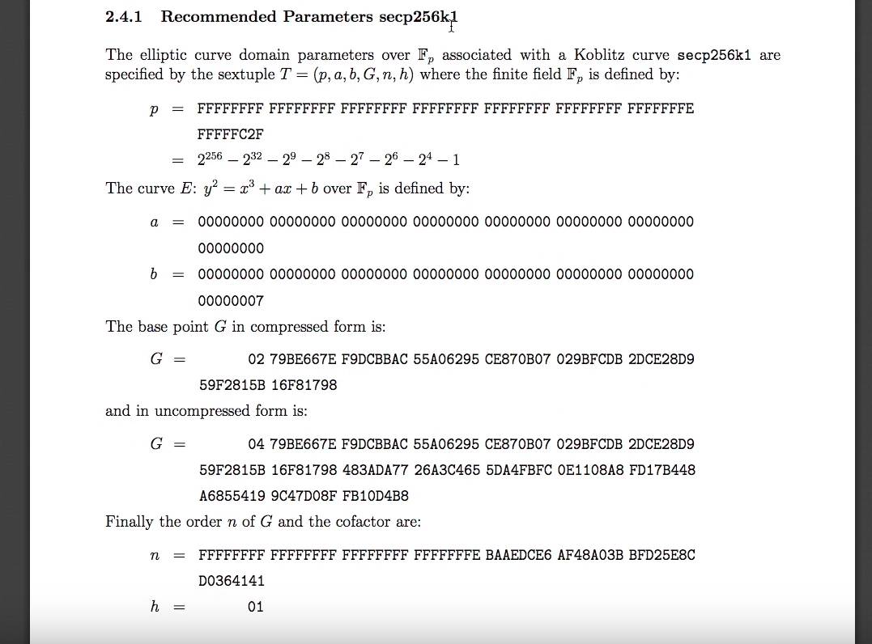
The 6-tuple parameters are:
Source: www.secg.org/sec2-v2.pdf
parameters a = 0, and b = 7 therefore the curve is of the form y^2 = x^3 + 7. P is a prime number and the field F(p) is the set of integers = {0, …, p-1}. Modulo p is also used in the equation where the EC equation with modulo operation: y^2 = x^3 + ax + b(mod p). G is the basepoint or the start point which is what everyone uses to generate the private/ pbulic key pair. G is a predetermined point (Gx, Gy). G can be expressed in two ways, first way: with prefix 02 represents the Gx ordinate (excluding the 02) the Gy value is then calculated from this value with the equation Gy = sqrt(Gx + 7), and the 04 prefix conatins the Gx and Gy ordinates starting from 79BE… for Gx and starting from 483ADA for Gy. N is the order of base point G where n determines the maximum value that can be turned into a private key, in other words it bounds a private key value to [1, n-1] (similar to how modulo bounds integer value) if a private key is begger than this number, or less than 1, it is an invalid private key. H is the cofactor and maintains a constant value of one.

There are two oeprations when calculating the resulting point given the two points on the curve (one of the points will always be the base point)
-Point Addition: adding two points on the elliptic curver where both points are not the same point. Geometrically this is the same as drawing a line from point P to point Q and the point of intersection (-R) is then reflected over the x axis to give point R. You need the following three equations to calculate point R on the elliptic curve, they are shown below.
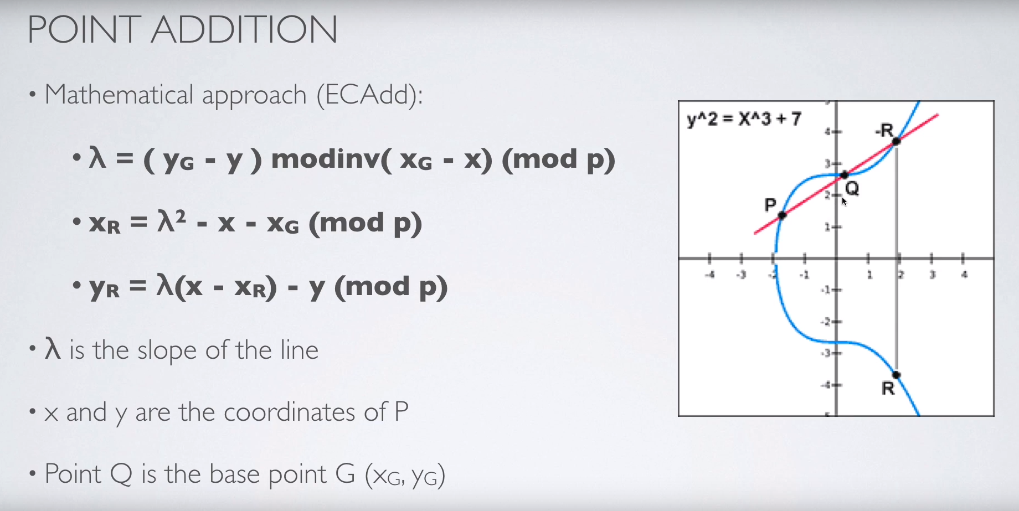
-Point Doubling is when both points P, Qhave the same coordinates (P = Q) e.g when starting the process of calculating a private/public key pair you only have the generator point to start off with, in this case you use this function. Geometrically a tangent line from point P is drawn and interesects the curve at a single point (-R) this point is then reflected over the x axis to generate the next point R. You also need three equations to calculate the point R, they are shown below
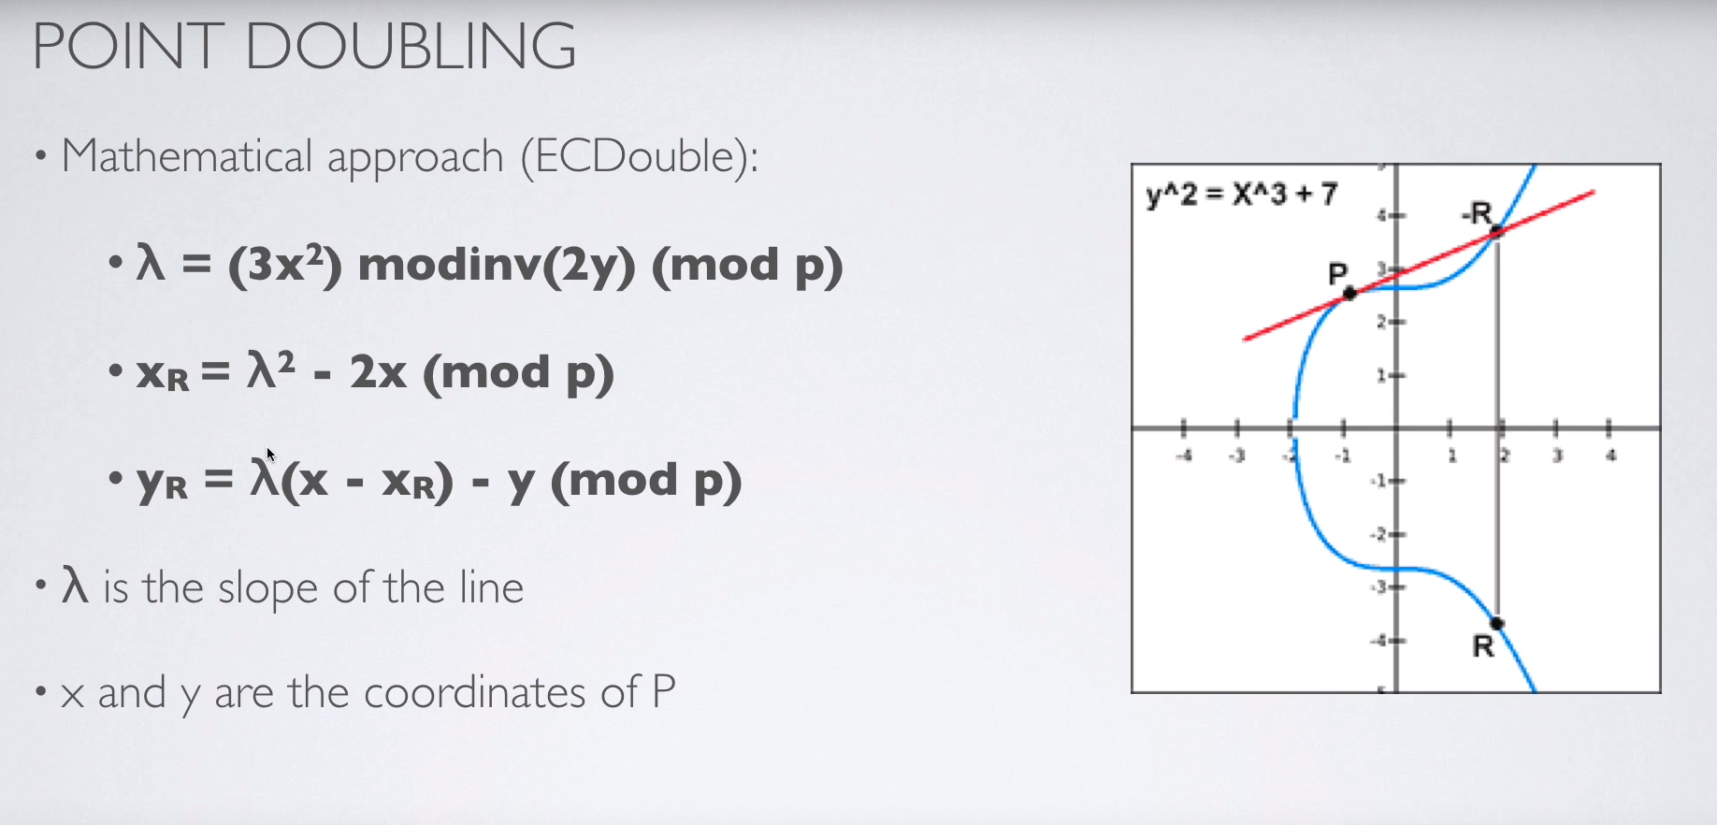
When coding this up, you would create two functions for each of the operations. Each operation woulf contain the equations needed to calculate the the R coordinate. Before calling either of the operations, you would check whether the P, Q coordinates are equa and execute the corresponmding function and increment the private key number after each successfulfunctionb operation call.
Sorce: https://www.youtube.com/watch?v=wpLQZhqdPaA

Since the private key is the number of times the R coordinate is generated from P and Q, the public key is simply derived from the final R coordinates value after N (private key value) operations (consisting of point and doubling operations). Therefore the public key is derived from the private key and is further compressed to form a bitcoin address one uses to receive bitcoins.

In order to compute the public key given a private key N, you have to preform elliptic curve multiplication. Elliptic Curve multiplication is defined as doing point addition n times. e.g. nP = P1 + P2 + P3 + …. + Pn. Therefore in order to calculate the public key (final pair of coordinates) you need to multiply the generator point by the private key. Since point addtion n times is exponential and inefficient. You can effectively combine point doubling and point addition. There are a number of algorithms to do point multiplication of elliptic curves, here is one example:
to multiply a private key n, by the generator point to find the public key, one first turns the private key into binary, and iterates through the binary and at everybinary digit they preform a point double on the coordinate AND if the binary is a 1 they also preform a point addition. If the binary is a 0 then only the point double operation is preformed. There are two variations of this method, if you start from the most significant bit of the binary, you first preform a point double before any potential point additions. If you are preforming the multiplication using the least significant bits of n then you preform any possible point additions before preforming the point doubling operation.
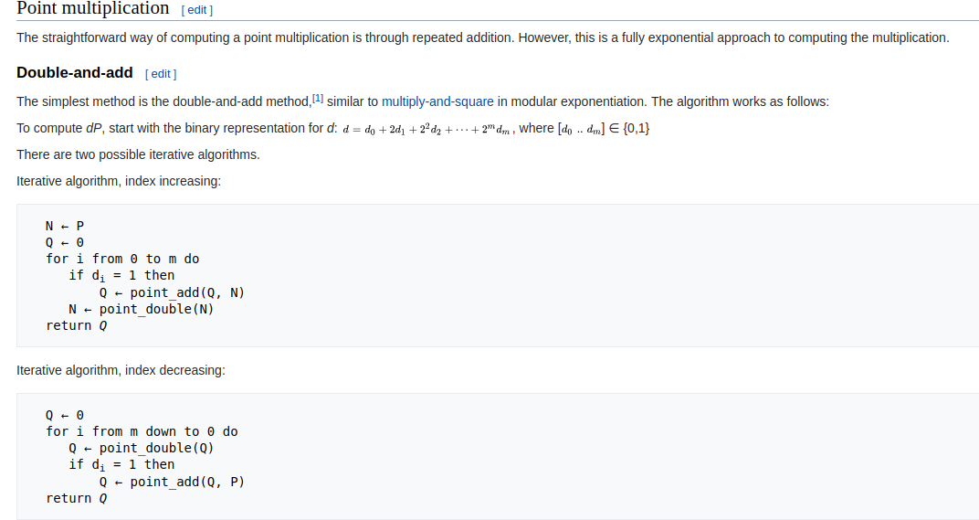
Source: https://en.wikipedia.org/wiki/Elliptic_curve_point_multiplication

Bitcoin addresses:
Using a randomly generated private key, you are then able to create a public key from the method discussed above, from the public key you can turn this into a compressed public key or leave it as a uncompressed public key. From the compressed public key you can transform this into a compressed public address. From the uncompressed public key, this can be turned into a uncompressed public key.
Private key (32 byte number)
Public key consists of a x and y coordinate each of which are 32 bytes
for the compressed public key this is simply the x coordinate prepended with either a 0x02 byte (if the y coordinate is even) or an 0x03 byte (if the y coordinate is odd) totalling to 33 bytes
Public addresses are 17 bytes
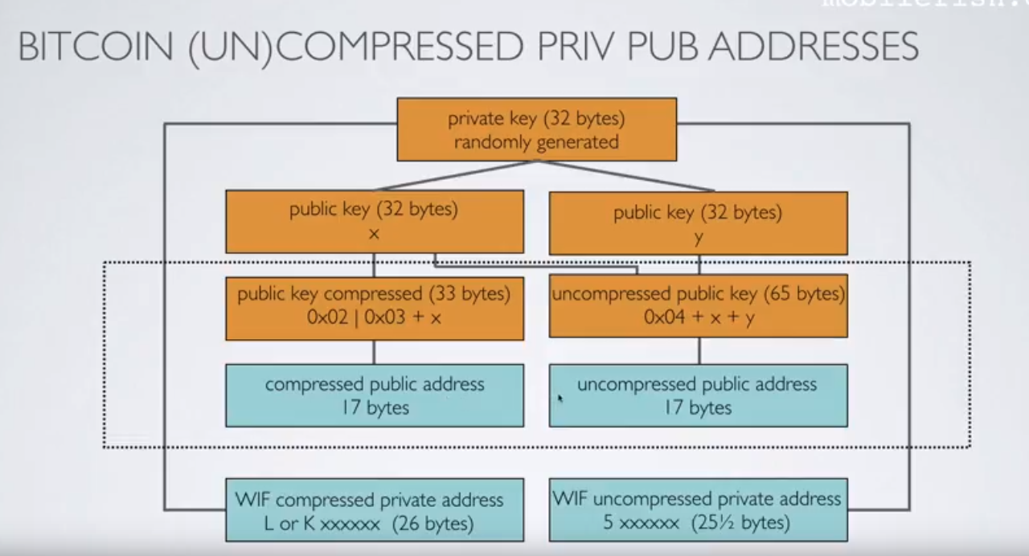
Source: https://www.youtube.com/watch?v=JWFeG2rgWY0&list=PLmL13yqb6OxdEgSoua2WuqHKBuIqvll0x&index=17
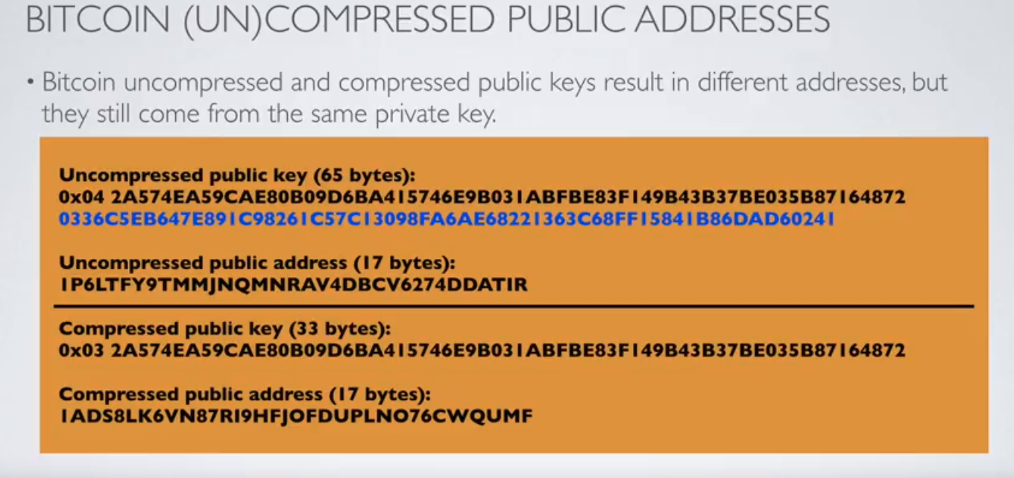
Source: https://www.youtube.com/watch?v=JWFeG2rgWY0&list=PLmL13yqb6OxdEgSoua2WuqHKBuIqvll0x&index=17

# Super simple Elliptic Curve Presentation. No imported libraries, wrappers, nothing.
# For educational purposes only. Remember to use Python 2.7.6 or lower. You'll need to make changes for Python 3.
# Below are the public specs for Bitcoin's curve - the secp256k1
Pcurve = 2**256 - 2**32 - 2**9 - 2**8 - 2**7 - 2**6 - 2**4 -1 # The proven prime
N=0xFFFFFFFFFFFFFFFFFFFFFFFFFFFFFFFEBAAEDCE6AF48A03BBFD25E8CD0364141 # Number of points in the field
Acurve = 0; Bcurve = 7 # These two defines the elliptic curve. y^2 = x^3 + Acurve * x + Bcurve
Gx = 55066263022277343669578718895168534326250603453777594175500187360389116729240
Gy = 32670510020758816978083085130507043184471273380659243275938904335757337482424
GPoint = (Gx,Gy) # This is our generator point. Trillions of dif ones possible
#Individual Transaction/Personal Information
privKey = 0xA0DC65FFCA799873CBEA0AC274015B9526505DAAAED385155425F7337704883E #replace with any private key
def modinv(a,n=Pcurve): #Extended Euclidean Algorithm/'division' in elliptic curves
lm, hm = 1,0
low, high = a%n,n
while low > 1:
ratio = high/low
nm, new = hm-lm*ratio, high-low*ratio
lm, low, hm, high = nm, new, lm, low
return lm % n
def ECadd(a,b): # Not true addition, invented for EC. Could have been called anything.
LamAdd = ((b[1]-a[1]) * modinv(b[0]-a[0],Pcurve)) % Pcurve
x = (LamAdd*LamAdd-a[0]-b[0]) % Pcurve
y = (LamAdd*(a[0]-x)-a[1]) % Pcurve
return (x,y)
def ECdouble(a): # This is called point doubling, also invented for EC.
Lam = ((3*a[0]*a[0]+Acurve) * modinv((2*a[1]),Pcurve)) % Pcurve
x = (Lam*Lam-2*a[0]) % Pcurve
y = (Lam*(a[0]-x)-a[1]) % Pcurve
return (x,y)
def EccMultiply(GenPoint,ScalarHex): #Double & add. Not true multiplication
if ScalarHex == 0 or ScalarHex >= N: raise Exception("Invalid Scalar/Private Key")
ScalarBin = str(bin(ScalarHex))[2:]
Q=GenPoint
for i in range (1, len(ScalarBin)): # This is invented EC multiplication.
Q=ECdouble(Q); # print "DUB", Q[0]; print
if ScalarBin[i] == "1":
Q=ECadd(Q,GenPoint); # print "ADD", Q[0]; print
return (Q)
print; print "******* Public Key Generation *********";
print
PublicKey = EccMultiply(GPoint,privKey)
print "the private key:";
print privKey; print
print "the uncompressed public key (not address):";
print PublicKey; print
print "the uncompressed public key (HEX):";
print "04" + "%064x" % PublicKey[0] + "%064x" % PublicKey[1];
print;
print "the official Public Key - compressed:";
if PublicKey[1] % 2 == 1: # If the Y value for the Public Key is odd.
print "03"+str(hex(PublicKey[0])[2:-1]).zfill(64)
else: # Or else, if the Y value is even.
print "02"+str(hex(PublicKey[0])[2:-1]).zfill(64)
Source: https://github.com/wobine/blackboard101/blob/master/EllipticCurvesPart4-PrivateKeyToPublicKey.py#L49

